**Rock Paper Scissors**

Project report

Submitted by:

Subhanshi Rawat (2K19/IT/126)

Mir Omid Mirzada (2K19/IT/152)

Under the supervision of

SWATI SHARDA

FACULTY SUPERVISOR



DEPARTMENT OF INFORMATION TECHNOLOGY  
DELHI TECHNOLOGICAL UNIVERSITY  
(Formerly Delhi College of Engineering) Bawana Road, Delhi –110042

**CANDIDATE’S DECLARATION**

We hereby declare that project report entitled **“ROCK PAPER SCISSOR GAME”** implemented using JavaScript / HTML / CSS submitted by (Mir Omid Mirzada, 2K19/IT/152) and (Subhanshi Rawat, 2K19/IT/126) to Delhi Technological University (DTU), Delhi is a record of original work done under the guidance of Prof. Swati Sharda for the course of **DISCRETE STRUCTURES**. All the codes and implementations are completely written by us.

Subhanshi Rawat (2K19/IT/126)

Mir Omid Mirzada (2K19/IT/152)

Date: 2nd Dec 2020 Place: New Delhi

DEPARTMENT OF INFORMATION TECHNOLOGY  
DELHI TECHNOLOGICAL UNIVERSITY  
(Formerly Delhi College of Engineering) Bawana Road, Delhi –110042

**CERTIFICATE**

This is to certify that Mir Omid Mirzada (2K19/IT/152) and Subhanshi Rawat (2K19/IT/126) of IT-2 batch Information technology department (IT) have successfully completed the project work entitled **“ROCK PAPER SCISSOR GAME”** implemented using JavaScript / HTML / CSS on **DISCRETE STRUCTURES** for Third Semester which is to be evaluated as the Mid Term Component.

Signature:

Place: -Delhi Ms. SWATI SHARDA

Date: - 2nd Dec 2020 FACULTY SUPERVISOR

Delhi Technological University

**ACKNOWLEDGMENT**

We would like to express my special thanks of gratitude to my teacher Prof. Swati Sharda as well as our college (Delhi Technological University, Delhi) which gave us the golden opportunity to do this wonderful project on the topic **“ROCK PAPER SCISSOR GAME”** implemented using JavaScript / HTML / CSS on **DISCRETE STRUCTURES**, which also helped us in doing a lot of Research and we came to know about so many new things we are really thankful to them.

Secondly, we would also like to thank our parents, classmates and friends who helped us in finalizing this project within the limited time frame.

**ABSTRACT**

Rock, Paper, Scissors is a simple hand game with many names and variations. It is played around the world and is commonly used as a way of coming to decisions. In some cases is even played for sport. The rules require that competing players use one hand to form one of three shapes at an agreed-upon time. The person that plays the strongest “object” is the winner of the game. It's that easy! Rock, Paper, Scissors is a simple game that anybody can play and win. There is no intrinsic advantage to the stronger, older, or more experienced opponent.

**Objective**

The familiar game of Rock, Paper, Scissors is played like this: at the same time, two players display one of three symbols: a rock, paper, or scissors. A rock beats scissors, scissors beat paper by cutting it, and paper beats rock by covering it. In this simulation, the computer has two different strategies that it can follow.

Rock, paper, scissors is an example of a zero-sum game without perfect information. Whenever one player wins, the other loses. We can express this game using a payoff matrix that explains what one player gains with each strategy the players use. In the payoff matrix below, the rows represent player 1's possible strategies while the columns represent player 2's possible strategies. 1 represents a win for player 1, 0 a tie, and -1 or 2 for a loss for player 1. So, for instance, the upper left entry is a 0 because if both players display rocks, they tie. The upper middle entry is a -1 or 2 because if player 1 displays a rock and player 2 displays paper, player 2 wins, and therefore, player 1 loses.

.

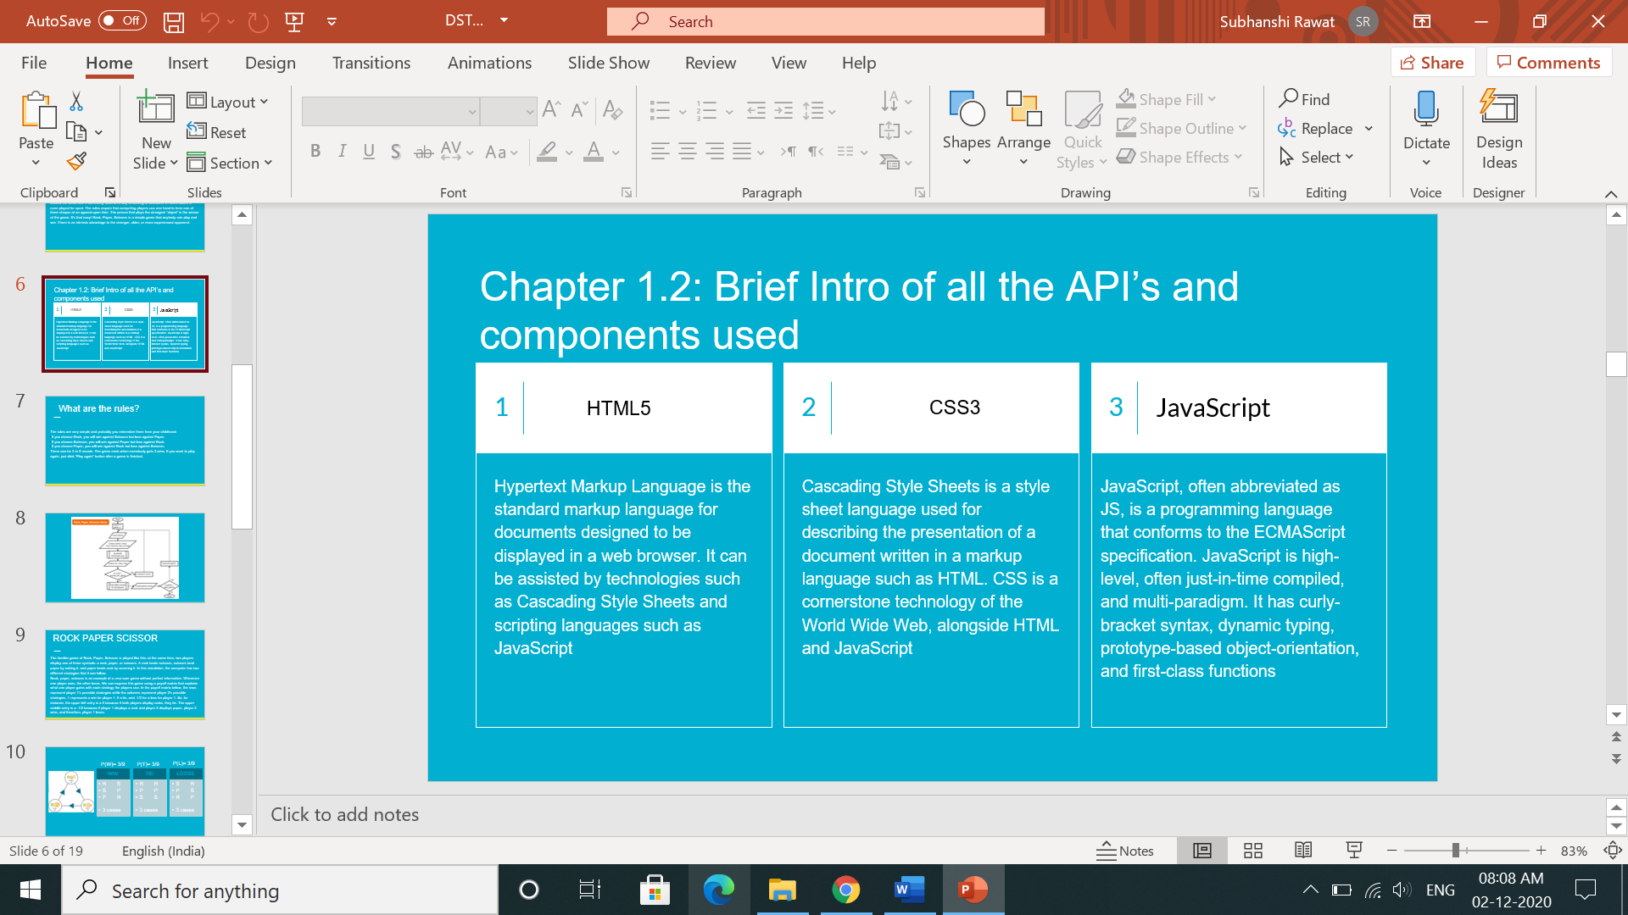

**GAME THEORY**

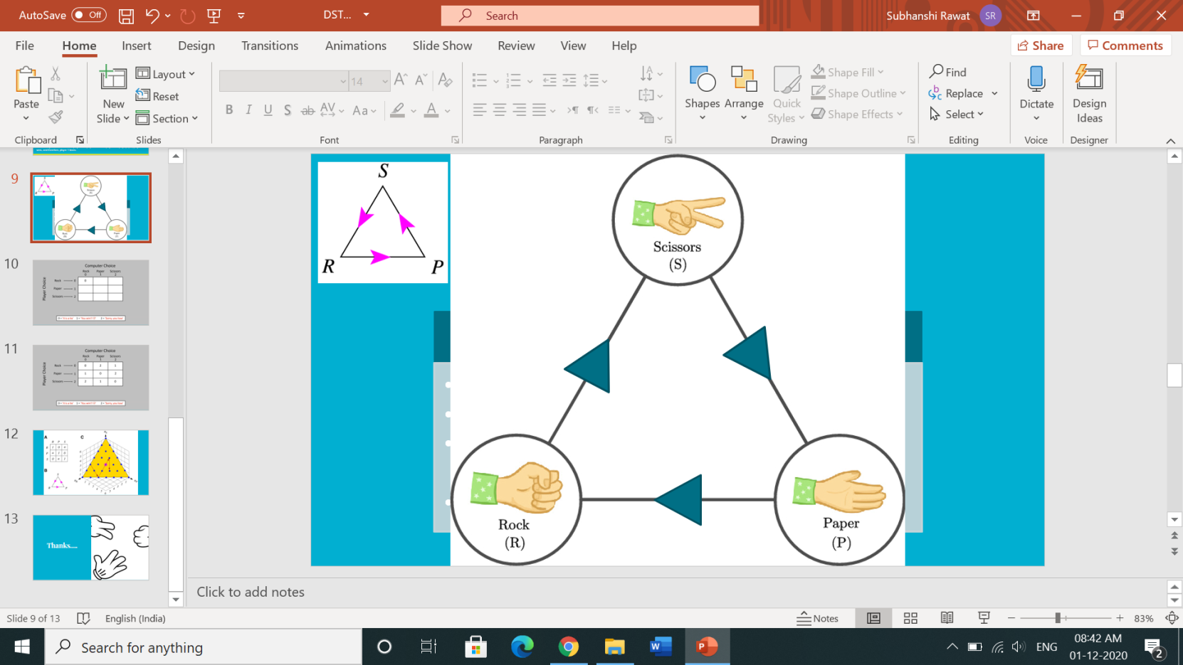

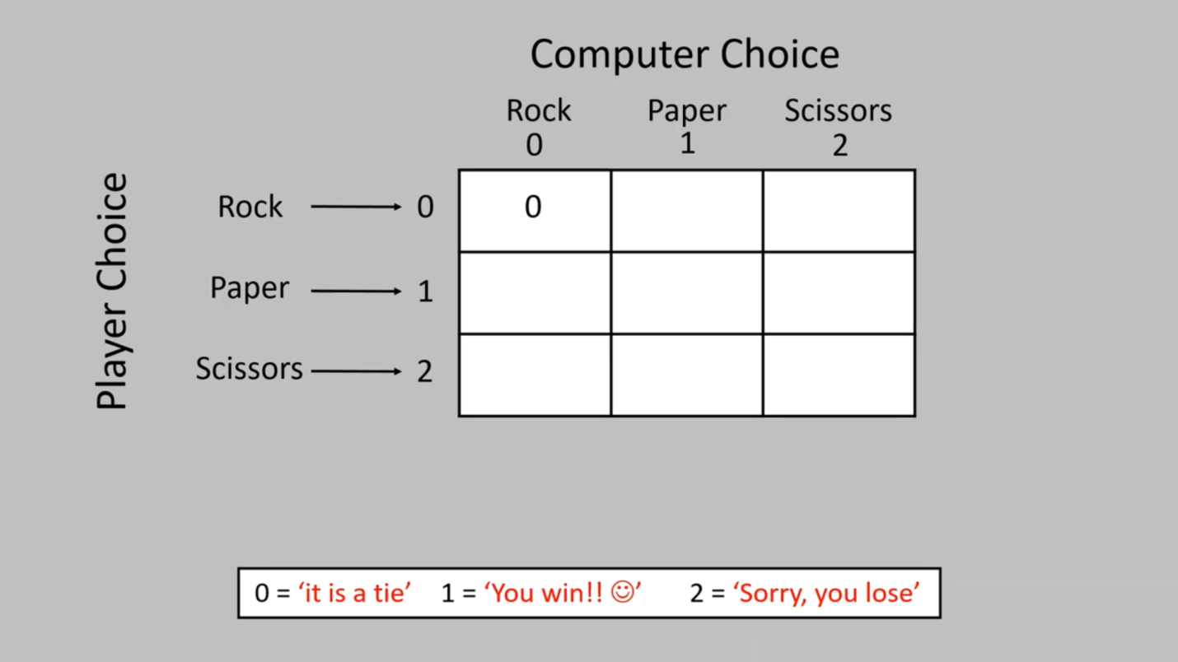

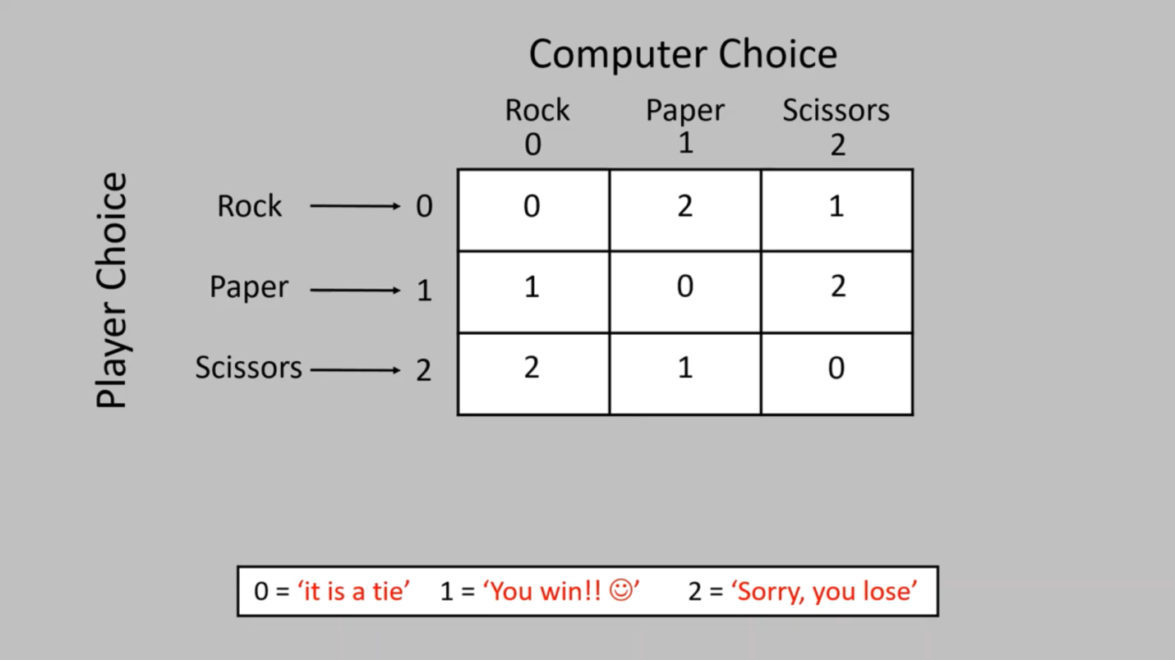

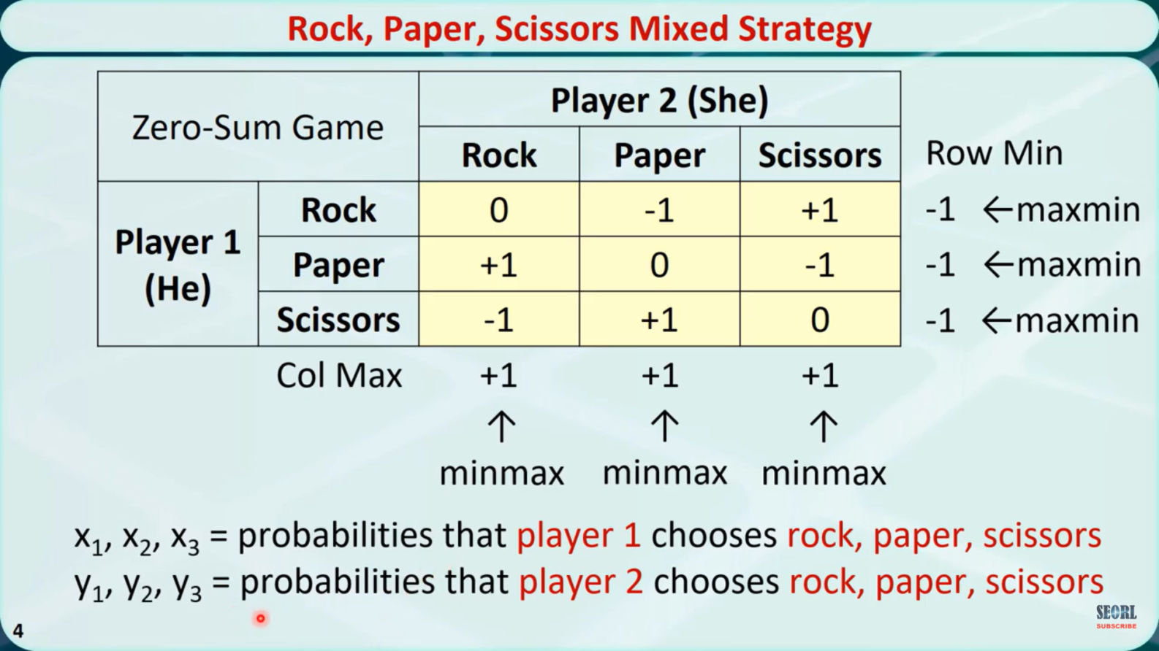

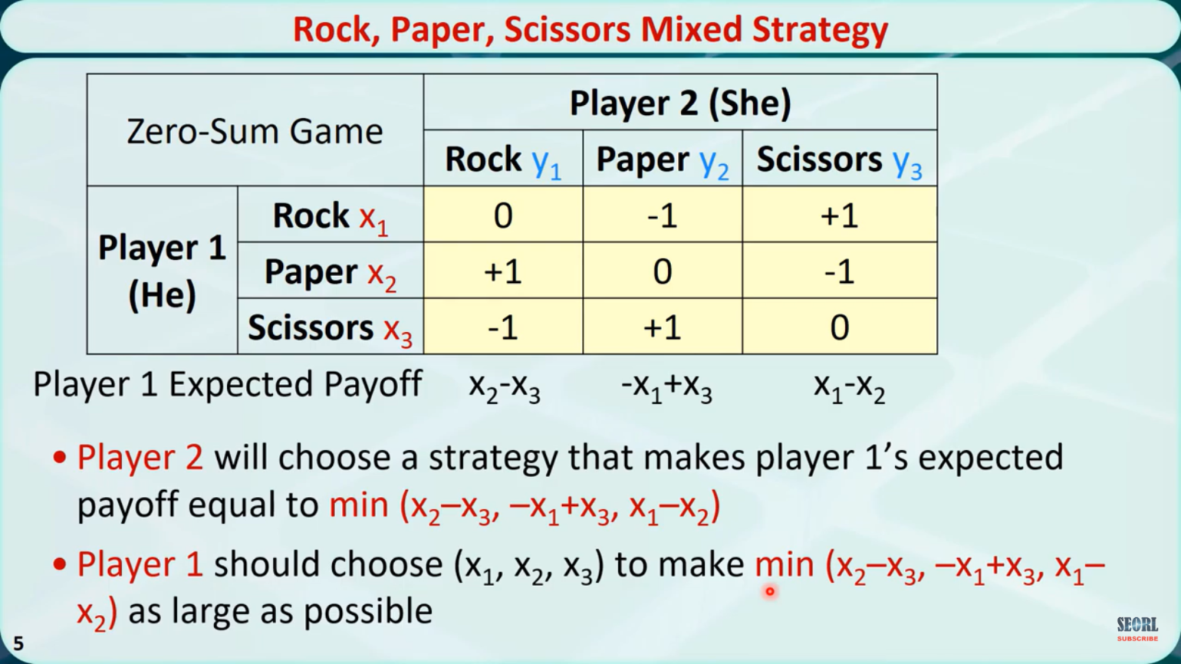

**Algorithm / Flowchart**

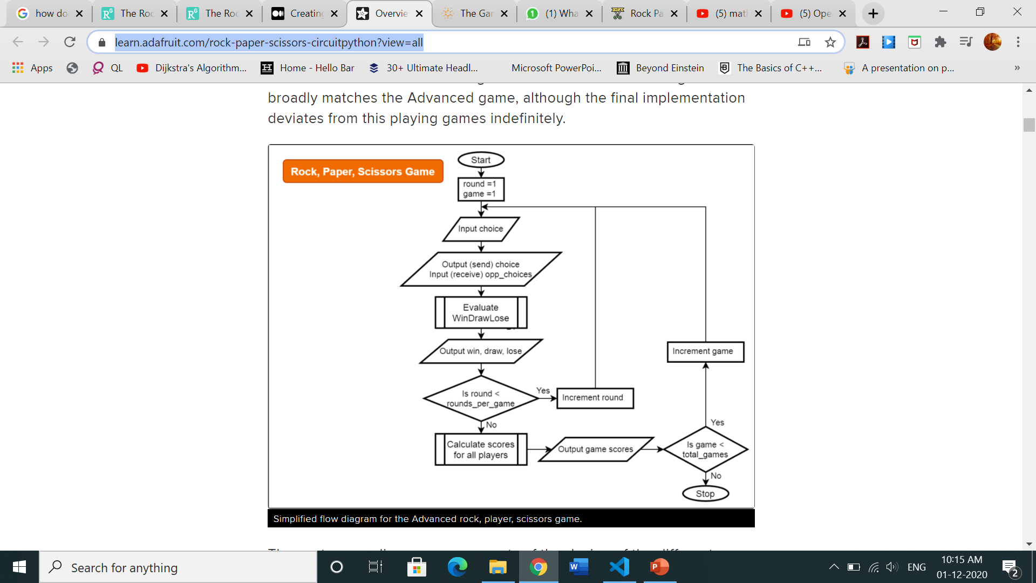

**CODE**

**Java Script (The Brain Code of our project )**

var userScore = 0;

var computerScore = 0;

const userScore_span = document.getElementById("user-score");

const computerScore_span = document.getElementById("computer-score");

const sccoreBoard_div = document.querySelector(".score-board");

const result_p = document.querySelector(".result > p");

const rock_div = document.getElementById("r");

const paper_div = document.getElementById("p");

const scissors_div = document.getElementById("s");

function computerChoice() {

    const choices = ['r', 'p', 's'];

    return choices[Math.floor(Math.random() * 3)];

}

function win(userInput, compChoice) {

    userScore++;

    userScore_span.innerHTML = userScore;

    computerScore_span.innerHTML = computerScore;

    if (userInput === 'r' && compChoice === 's') {

        result_p.innerHTML = `Computer chosed Scissors. You Win ✅🎉`;

    }

    else if (userInput === 'p' && compChoice === 'r') {

        result_p.innerHTML = `Computer chosed Rock. You Win ✅🎉`;

    }

    else if (userInput === 's' && compChoice === 'p') {

        result_p.innerHTML = `Computer chosed Paper. You Win ✅🎉`;

    }

    document.getElementById(userInput).classList.add('win');

    setTimeout(function () { document.getElementById(userInput).classList.remove('win'); }, 350);

}

function Lose(userInput, compChoice) {

    computerScore++;

    userScore_span.innerHTML = userScore;

    computerScore_span.innerHTML = computerScore;

    if (userInput === 'r' && compChoice === 'p') {

        result_p.innerHTML = "Computer chosed Paper  . You Lost ❌";

    }

    else if (userInput === 'p' && compChoice === 's') {

        result_p.innerHTML = `Computer chosed Scissors ✂ . You Lost ❌`;

    }

    else if (userInput === 's' && compChoice === 'r') {

        result_p.innerHTML = `Computer chosed Rock ⬛ . You Lost ❌`;

    }

    document.getElementById(userInput).classList.add('lose');

    setTimeout(function () { document.getElementById(userInput).classList.remove('lose'); }, 350);

}

function Draw(userInput, compChoice) {

    userScore_span.innerHTML = userScore;

    computerScore_span.innerHTML = computerScore;

    if (userInput === 'r' && compChoice === 'r') {

        result_p.innerHTML = `Computer chosed Rock ⬛ . It's a Draw.`;

    }

    else if (userInput === 'p' && compChoice === 'p') {

        result_p.innerHTML = `Computer chosed Paper  . It's a Draw.`;

    }

    else if (userInput === 's' && compChoice === 's') {

        result_p.innerHTML = `Computer chosed Scissors ✂ . It's a Draw.`;

    }

    document.getElementById(userInput).classList.add('draw');

    setTimeout(function () { document.getElementById(userInput).classList.remove('draw'); }, 350);

}

function game(userInput) {

    const compChoice = computerChoice();

    const UserChoice = userInput + compChoice;

    if (UserChoice === "rs" || UserChoice === "pr" || UserChoice === "sp") {

        win(userInput, compChoice);

        console.log("Win");

    }

    else if (UserChoice === "rp" || UserChoice === "ps" || UserChoice === "sr") {

        Lose(userInput, compChoice);

        console.log("Lose");

    }

    else if (UserChoice === "rr" || UserChoice === "pp" || UserChoice === "ss") {

        Draw(userInput, compChoice);

        console.log("Draw");

    }

}

function main() {

    rock_div.addEventListener('click', function () {

        game('r');

    })

    paper_div.addEventListener('click', function () {

        game('p');

    })

    scissors_div.addEventListener('click', function () {

        game('s');

    })

}

main();

**OUTPUT**

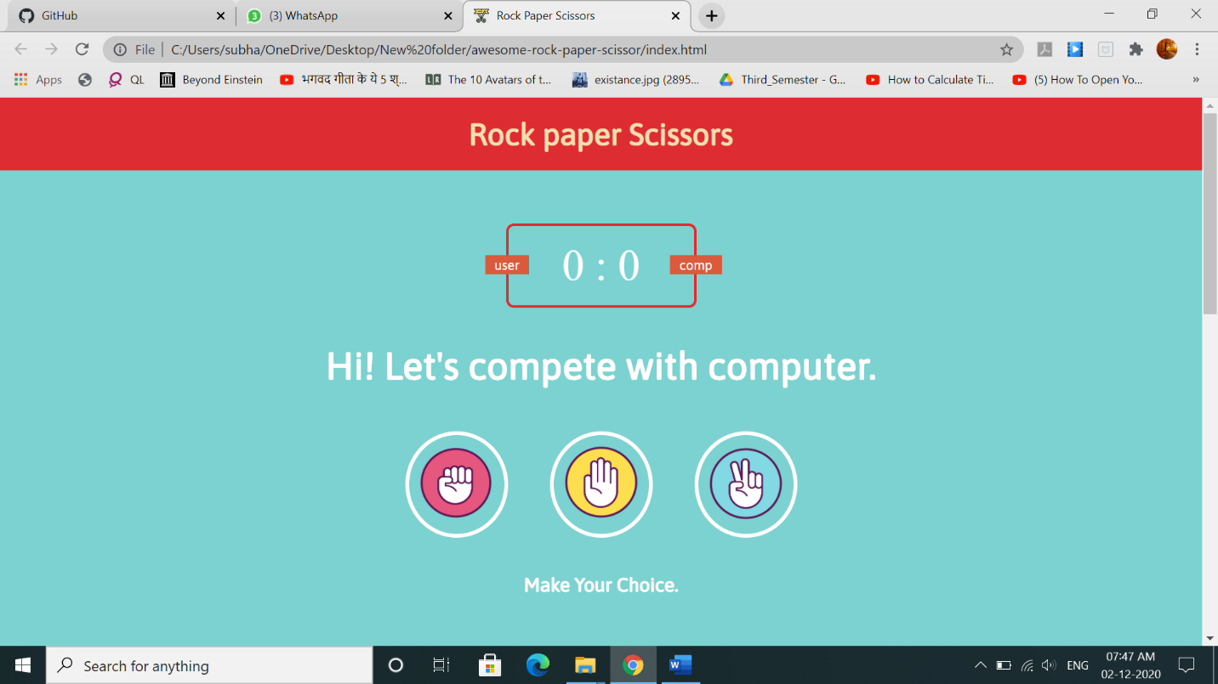Starting

Playing stone as the first move

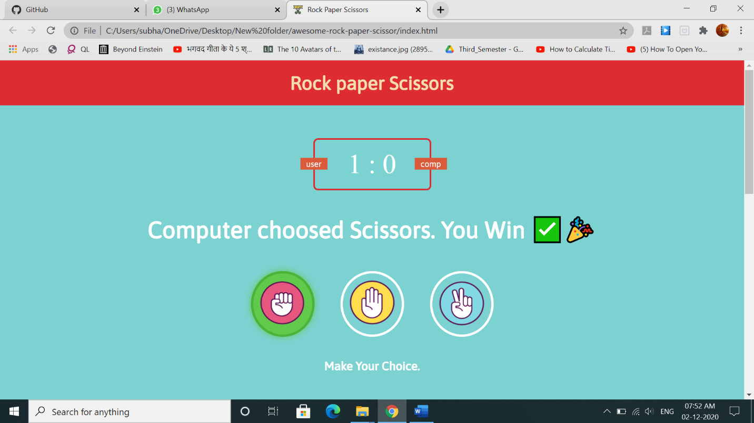

Increment in the player score by 1

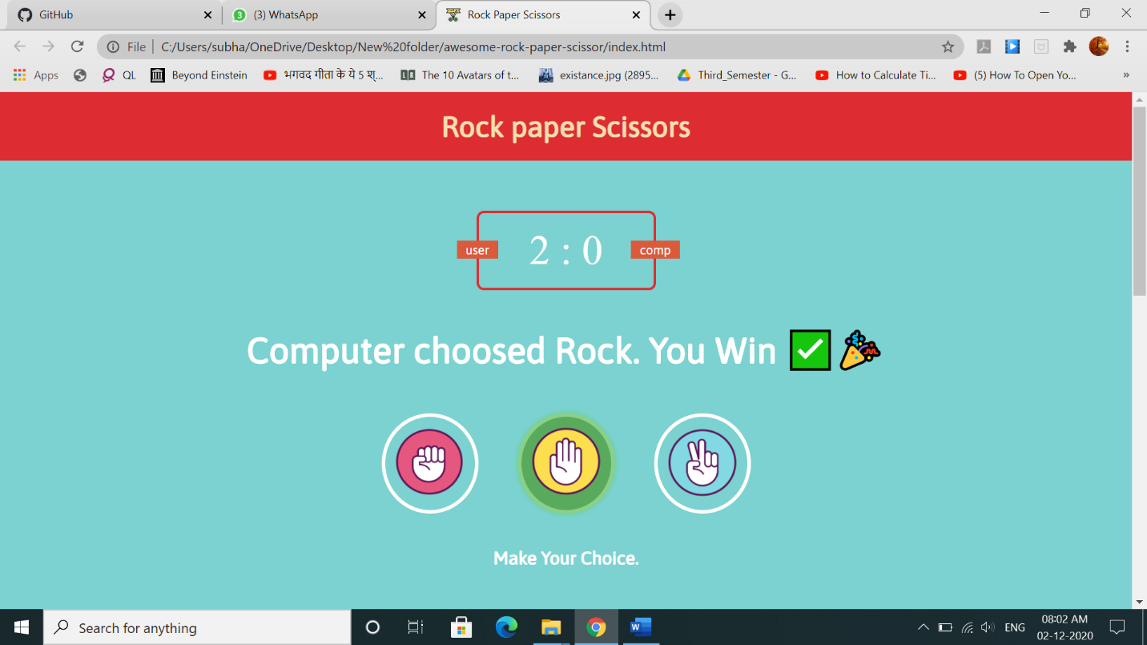Playing paper as the second move

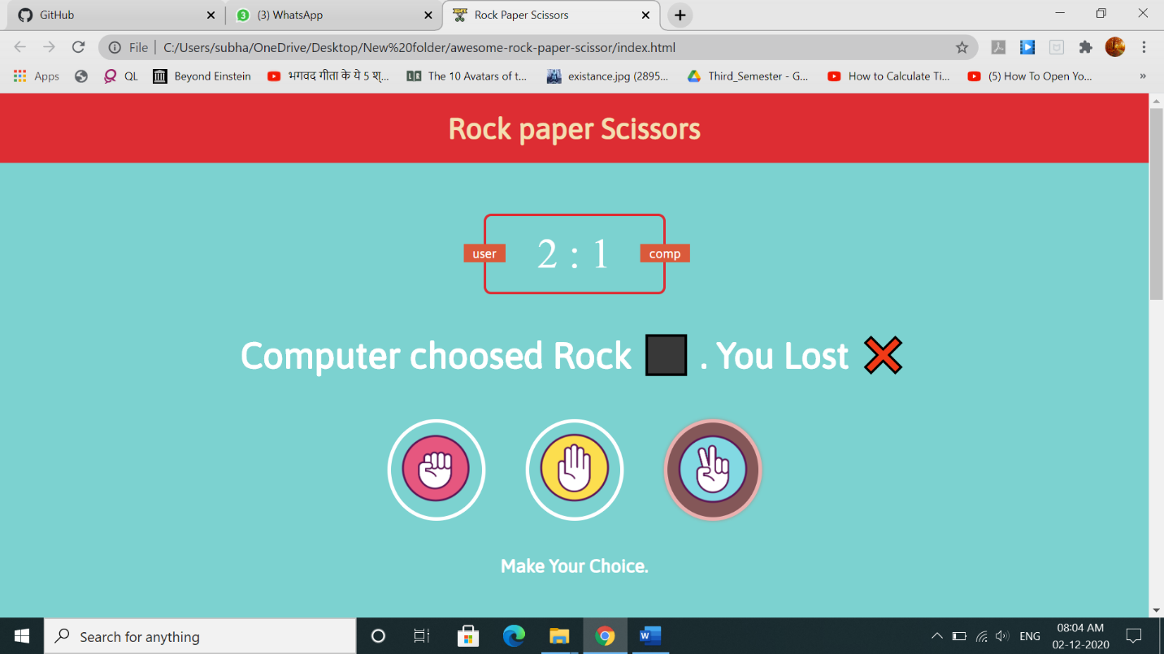Playing scissors as the third move

**REFERENCES**

1. <https://learn.adafruit.com/rock-paper-scissors-circuitpython?view=all>
2. <https://www.quantamagazine.org/the-game-theory-math-behind-rock-paper-scissors-20180402/>
3. <https://www.researchgate.net/figure/The-Rock-Paper-Scissors-game-A-The-payoff-matrix-Each-matrix-element-is-the-payoff-of_fig1_263200849>
4. <https://www.researchgate.net/figure/The-Rock-Paper-Scissors-game-A-Each-matrix-entry-specifies-the-row-actions-payoff_fig1_261761603>